- Initial load of the template:
Loads all tinymce config based tools from studio perfectly
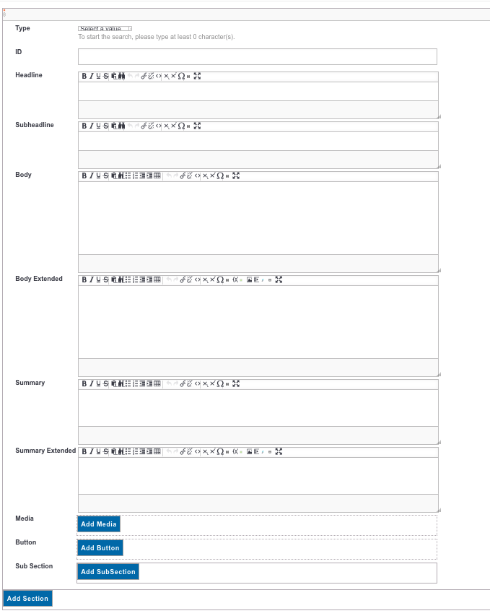

- On Edit screen: added a button section which has different set of tool bar.
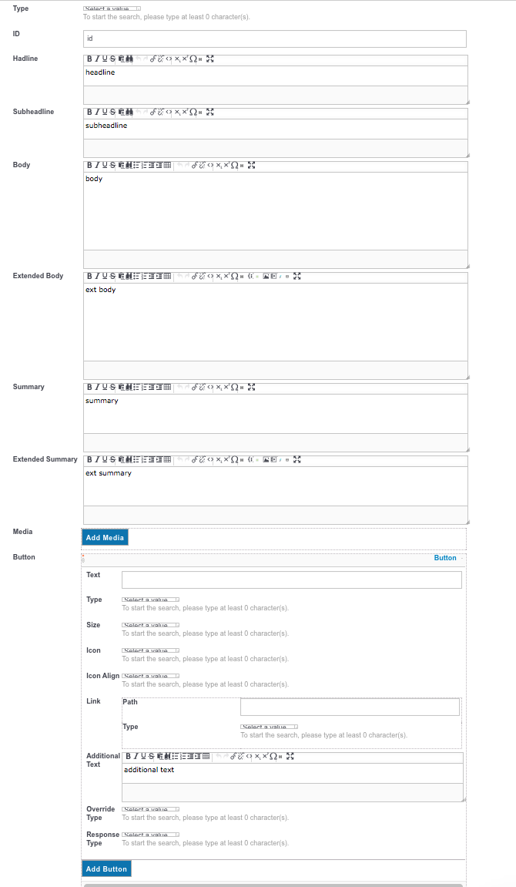
Added a section: Which reset everything to last tinymce toolbar set.

Added a subsection also resets everything to last tinymce toolbar set.

