NUXEO UNIVERSITY

Nuxeo Backend Basics Certification

Certification description

- Certification program

The Nuxeo certification is divided into four areas, covering every aspect of the Nuxeo Platform:
- Configuration with Nuxeo Studio: Nuxeo Studio skills, with Nuxeo Studio Modeler and Nuxeo Studio Designer
- Frontend development: Nuxeo REST API, development of custom applications based upon a Nuxeo Repository, Nuxeo Elements.
- Backend development: Basic JAVA elements as operations and listeners, components creation, use of Nuxeo CLI.
- Admin / Architecture: Clustering, Installation and customization, Data storage, Monitoring, Multi-tenancy.
Each area is divided into three grades: Associate, Expert and Master

The certification path is described by the picture below:
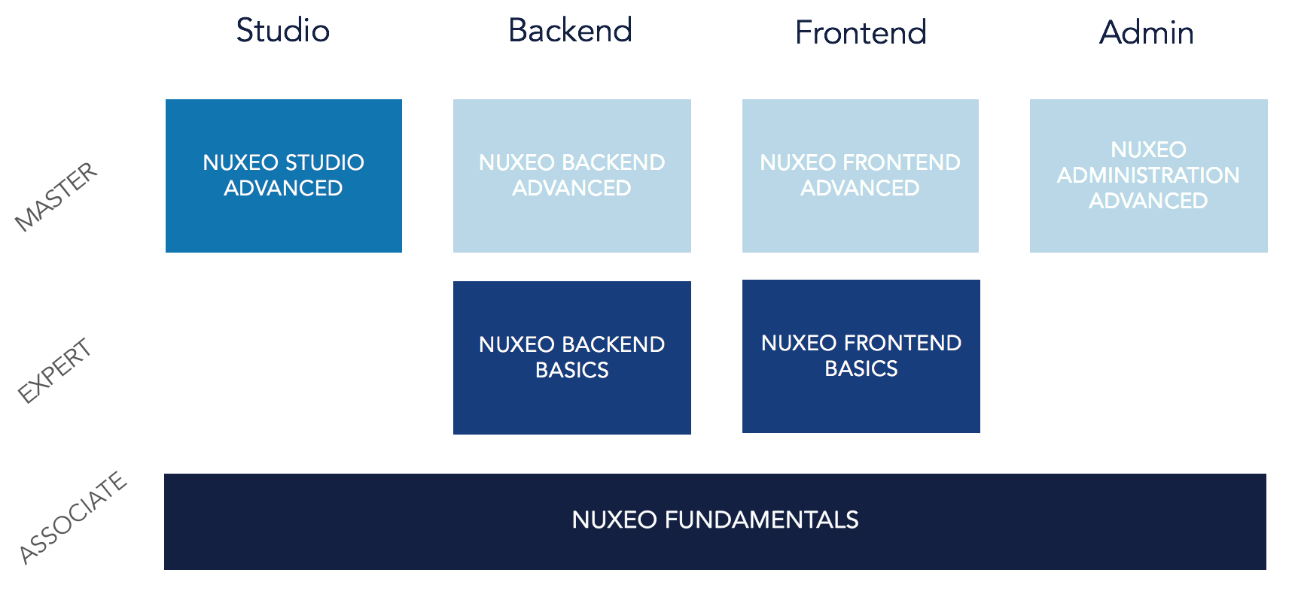

- Exam Topic

For the Nuxeo Bakcend Basics Certification, the candidates are tested on their ability to:
- To understand the Nuxeo development principles (60%)
  - Java (70%)
  - JSF (30%)
- To provide a basic Nuxeo code contribution (40%)

- Exam prerequisites

It is necessary to pass the Nuxeo Fundamentals Certification in order to take the exam

- Exam Format

The exam is composed of:
- Two quizzes of 10 questions on this examination. You are given 10 minutes to complete each quiz. A passing score of 60% is needed.
- An online assessment with no time limitation. Your code contribution will be evaluated by the Nuxeo University Team.
The quizzes and the online assessments must be both passed to be recognized as Nuxeo Backend Certified
To answer a question, select from one or more options. A response is considered correct only when all valid answers are selected.
Questions are multiple choice. Some questions have more than one correct answer. In this case, all correct answers must be selected. Correct answer(s) should appear obvious for the candidate.

- Resources
To prepare the exam, we advise you to read the following content:
- Java
  - One of our blog post about CoreSession management
- JSF
  - Documentation page about Nuxeo JSF UI
  - Technical overview of the Nuxeo Platform
  - Table to check JSF UI features
  - How to customize the JSF UI with Nuxeo Studio

- Recommended training

We highly recommend you to complete the following courses in Nuxeo University:
- The Nuxeo University course on Developer basics
- The Nuxeo University course on Extension Points
- The Nuxeo University course about business logic implementation

- Tip

It is allowed and recommended to have a running Nuxeo Instance with a running IDE before taking the exam.

- Certification policy and NDA

This exam is confidential and is protected. It is made available to you, the examinee, solely for the purpose of certification in the technical area referenced in the title of this exam. You are expressly prohibited from disclosing, publishing, reproducing, or transmitting this exam, in whole or in part, in any form or by any means, verbal or written, electronic or mechanical, for any purpose, without the prior express written permission of Nuxeo.
You're also engaged to respect the certification policy:
- 14 days after the first attempt
- 1 month after the second attempt
- You have 3 attempts to complete the certification
- Do not use several email addresses or multiple accounts to register
If these terms are not respected, Nuxeo will automatically revoke all the user's certifications and access to the Nuxeo University platform.

