Home > Blog > Learn the Nuxeo Platform on Demand - Introducing Nuxeo University
Learn the Nuxeo Platform on Demand – Introducing Nuxeo University

THU 09 JULY 2015 BY BERTRAND CHAUVIN
The Nuxeo Platform is so highly customizable and extensible, there’s a LOT to learn about it. Quite often during a Nuxeo training, users and developers will realize that the platform has much more to offer than they had ever imagined. As they continue to further explore the Nuxeo Platform, they realise that they can build almost anything with it! All they need is to gain some familiarity with the platform and its different features.
Mastering such a large and powerful platform is best achieved iteratively, by learning what you need, when you need it. So, we have been thinking about how we can provide you with a more agile learning process. We reached the conclusion that the most appropriate way is to build a new tool – a tool that will help you learn what you need and when you need at your own pace.
Introducing Learning On Demand with Nuxeo University
Let me introduce you to Nuxeo University – the tool that provides free, unlimited access to Nuxeo Platform video training. Its goal is to help Nuxeo users and developers increase their proficiency and accelerate learning by offering short on- demand videos that cover all subjects related to the platform. It will also guide you to the appropriate documentation or resources wherever available.
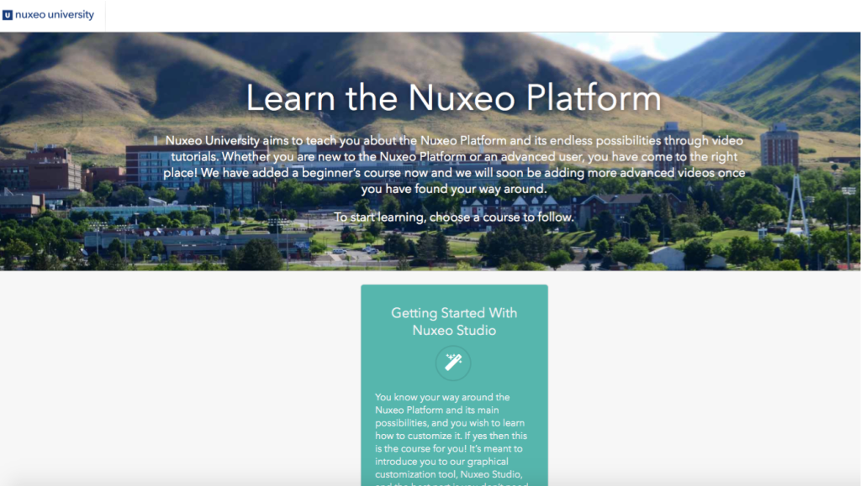

Whether you are new to the Nuxeo Platform or an advanced user already, Nuxeo University will act as a starting point to help you learn about the platform’s endless possibilities. The on-demand courses will allow you to watch any or all of the videos at your own pace and time. Built around thematic courses for all levels, each course will take you through a specific aspect of the platform, so that you can get the most out of it.
As of today, Nuxeo University is at an early stage and is offering one course to get you started with Nuxeo Studio This course includes customizing the look and feel of your application, designing your own content model, and creating our own business logic – all wrapped up in 8 short videos!
Very soon we will be adding more courses – one on the Nuxeo Platform’s main out of the box features and another regarding REST API usage for advanced users. Our plan is to cover all aspects of the platform; this means a lot more videos for you! Your ideas and requests are more than welcome. Let us know what you need or want to see first!
You will see major improvements in the functionality of Nuxeo University as well. Expect search, cherry-picking videos, and much more in the near future!
This great addition to our existing resources will make learning the Nuxeo Platform easier, faster, and fun! Join us in celebrating its launch and check it out here: university.nuxeo.io
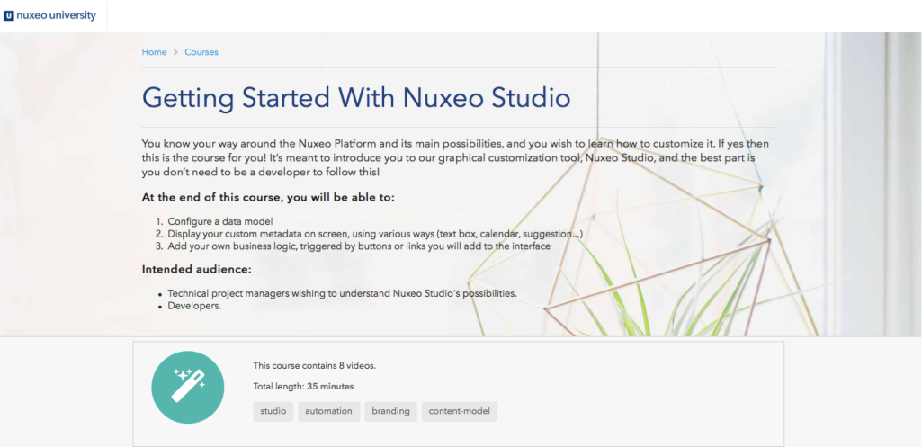

Categories
Industry Insight (http://www.nuxeo.com/blog- cat/industry-insight/)
Nuxeo Updates (http://www.nuxeo.com/blog- cat/updates/)
Product & Development (http://www.nuxeo.com/blog- cat/development/)
Popular Posts
How to speed up the Android Emulator by up to 400% (http://www.nuxeo.com/blog/speeding- up-the-android-emulator/)
From JSF to AngularJS: A UI Rewrite Story (http://www.nuxeo.com/blog/jsf- angularjs-ui-rewrite-story/)
Using HttpClient properly to avoid CLOSE_WAIT TCP connections (http://www.nuxeo.com/blog/using- httpclient-properly-avoid-closewait-tcp- connections/)
Using Docker as a Jenkins Cloud Provider (http://www.nuxeo.com/blog/docker- jenkins-cloud-provider/)
CoreOS Monitoring with Diamond and Graphite (http://www.nuxeo.com/blog/coreos- monitoring-diamond-graphite/)
Dump and load foreign subversion repositories using svnadmin and svndumpfilter (http://www.nuxeo.com/blog/dump-load-

